**ST.LUKE BAANABAKINTU PRIMARY SCHOOL**

**QULITY CHECK EXAMINATIONS 2024**

**PRIMARY TWO**

Name:…………………………………………………………………………….

School:……………………………………………………………………………

District: …………………………………………………………………………..

Time : 2hrs 15mins

1. **Fill in the correct word**
   1. The bird is flying _______________ the tree.
   2. Do not lean ___________________ the wall.
   3. Who was sitting __________________ the stool?
2. **Join to make one word**
   1. Class + teacher _____________________________
   2. Bed + room _____________________________
   3. Flower + pot _____________________________
3. **Give one word for many**
   1. Beds, chairs, tables and cupboards are ____________ (b) Knives, forks and spoons used for eating are ____________
4. **Read and draw pictures.**
   1. The girl is lying under the tree.
   2. The boys are playing soccer.

1. **Expand these numbers correctly**

40 = __________________________ 93 = __________________________

802 = __________________________

1. **Write the place value of the circled figures.**
   1. 7 3 0 = ___________________________
   2. 5 2 = ___________________________
   3. 9 3 0 = ___________________________
2. **Work out:**
   1. 3 + 2 =



* 1. 5 - 3 =



1. **Draw these shapes**
   1. Triangle (b) Rectangle

1. Write these figures in words

(a) 1st = _______________ (b) 14 = _______________

(c) 203 = __________________________

2. Complete the number sequence

(d) 3, 6, ____, 12, 15, ______, 21.

(e) 90, 80, ___, ____, 50, 40, ___, ___, 10.

**Literacy I**

**Theme: Our Environment**

NAME: ____________________________________STREAM___________

1. **Fill in the missing letters** f__uit lea__es __oot st__m
2. **Use the words in the table below to complete the composition correctly.**

|  |  |  |  |  |  |
| --- | --- | --- | --- | --- | --- |
| people, | environment, | non-living, | chairs, | living, | land |

__________________ are the things around us. Things which have life are called ____________________ things. Examples of living things are:- plants, animals, birds and ___________________. Things which do not have life are called __________________ things. Examples of non living thing are:- stones, pens, ______________, balls and shoes. People grow crops on ________________ and graze animals grass.

1. **Fill small words from the big words.**
   1. teacher _________________ forest ____________________
2. **Re-arrange the words to make correct sentences**
   1. sells fish monger a fish

______________________________________________________ (b) chasing is a rat cat a

______________________________________________________ (c) over the flying trees the bird is.

5.**Re-arrange the sentences to make a meaningful story** Then I board it and move.

After school, I wait for a taxi

When I reach, I ask the driver to stop When a taxi comes, I stop it.

I pay money to the conductor and move out.

(a) ____________________________________________________

(b) ___________________________________________________

(c) __________________________________________________

(d) ________________________________________

## LITERACY II

## 1)Name any two sources of food.

* + 1. _________________________________________________
    2. _________________________________________________

1. Smoking is one of the ways of preserving food. Give three other ways of preserving food.
   * 1. _________________________________________________
     2. _________________________________________________
     3. _________________________________________________
2. Draw and name any two fruits you know

|  |  |
| --- | --- |
|  |  |
|  |  |

1. Why do we boil water for drinking?

________________________________________________________

1. What is personal hygiene?

____________________________________________________

1. **Match tools to their uses**

Slasher scrubbing

Rake sweeping

Broom slashing

Brush collecting rubbish

1. Mention four people found at school.
   * 1. _________________________________________________
     2. _________________________________________________ (iii) _________________________________________________

(iv) _________________________________________________

1. Draw the members of a nuclear family.
2. Write the motto of your school.

13. Write down two reasons why animals move from one place to another.

(i) _________________________________________________

(ii) _________________________________________________

14. What is a weapon?

________________________________________________________

**ENGLISH**

* 1. **Make sentences**

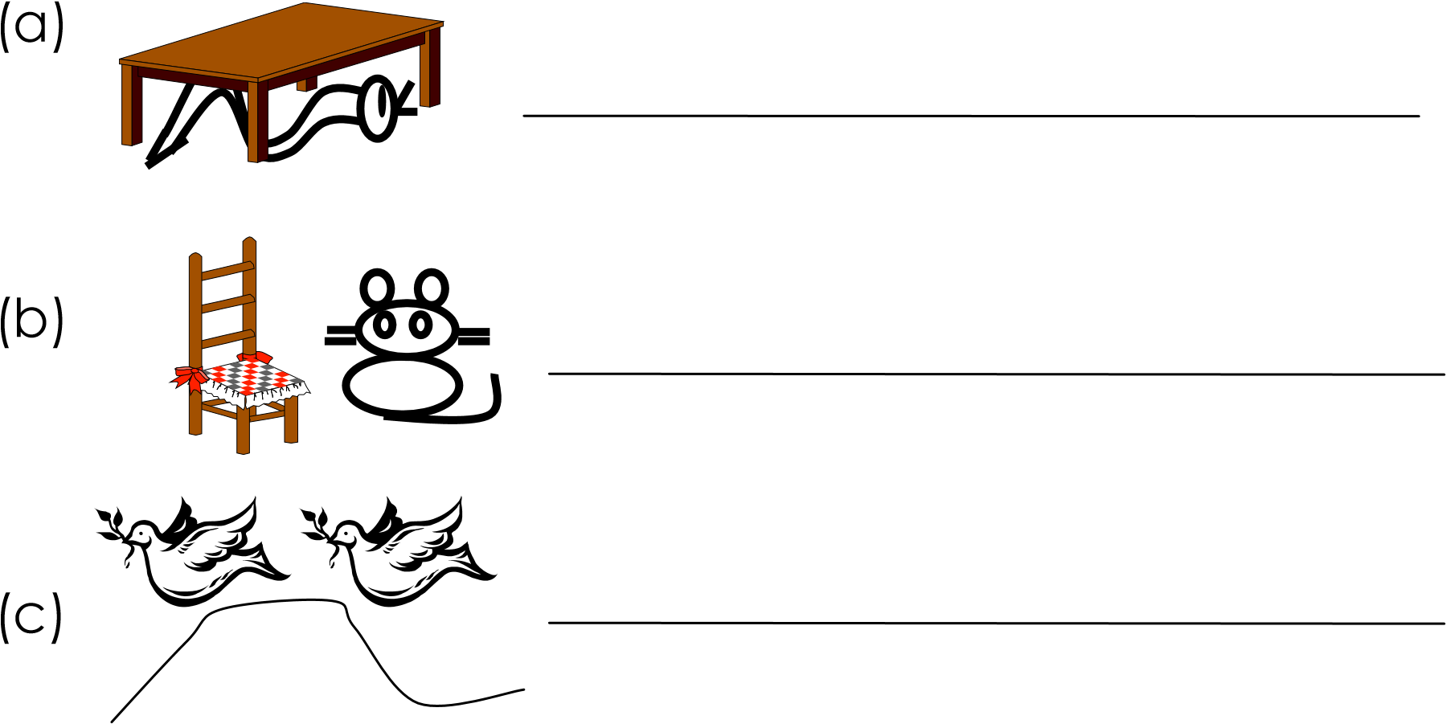

* 1. **Fill in the correct tense**
     1. Peter _________________ to school every morning. (go)
     2. Who ________________ your uniform yesterday. (wash)
     3. They are _________________ to visit today. (come)
     4. I __________________ fish every weekend. (eat)
     5. **Write in full**
     6. Tr. ______________________________
     7. Dr. _______________________________
     8. Can’t _______________________________

1. Write out the adjectives

(a) I saw a very tall man yesterday.

____________________________________________________ (b) Father has a new car.

____________________________________________________ (c) Why is the box heavy?

____________________________________________________

2. Fill in the missing letters

(a) cassa ___a (b) p___wpaw (c) ya ___

3. Give the pronouns of the underlined words. (a) Joan and I were absent.

____________________________________________________

(b) Where did Anna go?

____________________________________________________ (c) Mother has a big bag.

____________________________________________________ (d) The children are shouting.

____________________________________________________ (e) How old is Alex?

____________________________________________________